Talula Pontuti

Week 4 Exercise

02/09/2022

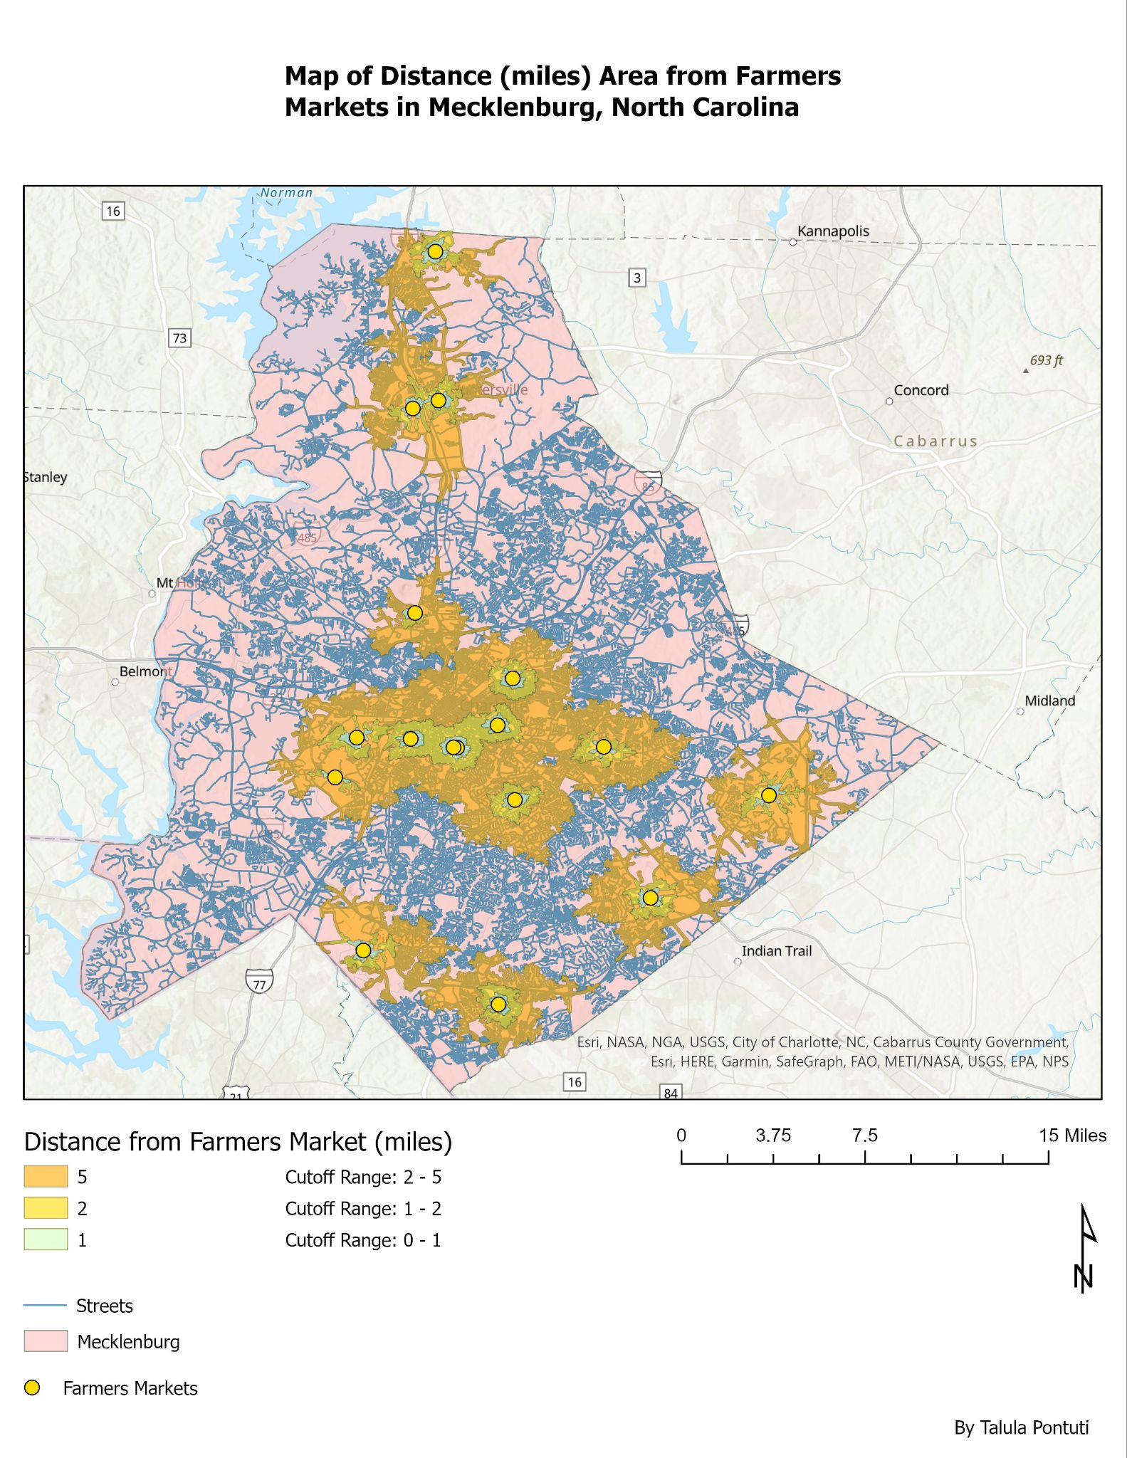

In past work positions, we focused on increasing food access across Salt Lake City, and one thing we were thinking about is reducing the areas that we viewed as an adequate distance to have people travel for food, so that is why I chose smaller distance areas for these farmers markets. It’s good to think about if people are able to walk, bike, or take public transportation to these food access points as a goal. As a result, in this map it is clear to see that most of the access to farmers markets are in the center of the city and it could be helpful to expand more markets out depending on other major residential areas and related food access points.